2nd Preparatory
Study this Project for the Computer Practical Exam:
1- From “Start” button, select ”Notepad”.
2- start typing the next codes:
<html>
<head>
<title>
</title>
</head>
<body>
</body>
</html>
3- Add the following:
- Inside “Title” tags: write (RCG) to appear on the title tab of the webpage.
- Inside “body” tags: write the following:
<font size=”7” color=”red”>
<center> Advices for the daily living </center>
</font>
<font size=”5” color=”blue”>
<br> Live simply
<br> Care deeply
<br> Speak kindly
</font>
4- Save the text file as follows:
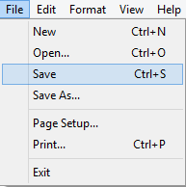
- From “File” menu, select “Save”.

- Save your text file on the desktop and write (home.html) on the “File name” box then press “Save”.
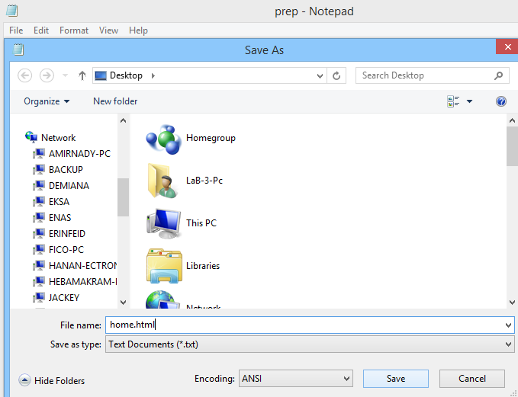

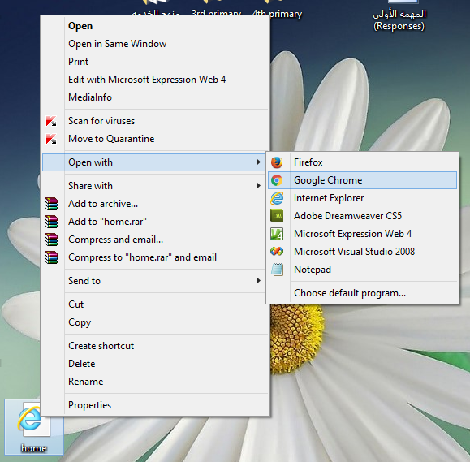
- Right click on the file icon on the desktop, select “Open with” option then choose “Google Chrome”

- The webpage will appears as follows:
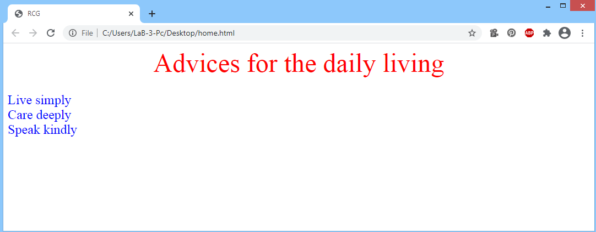
Note:
Study from page 23 till page 28

